**Introduction to Power BI**

Power BI, developed by Microsoft, is a robust business analytics tool enabling users to visualize data and share insights through interactive reports and dashboards. It facilitates connection to diverse data sources, data transformation, report creation, and sharing. Its user-friendly interface and powerful features make it a top choice for businesses aiming to extract actionable insights from their data.

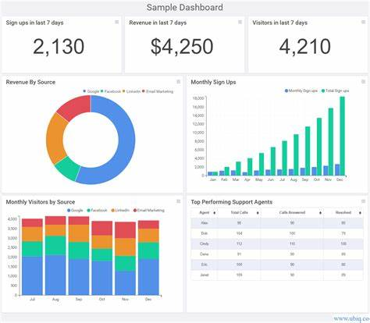

**Component of Power BI**

1. **Power BI Desktop**: A desktop application for creating data models, designing reports, and building dashboards. It's used for data preparation and visualization before publishing to the Power BI Service.
2. **Power BI Service**: A cloud-based service for publishing, sharing, and collaborating on Power BI reports and dashboards. It allows users to access reports through web browsers and mobile devices.
3. **Power BI Gateway**: A bridge that connects Power BI Service to on-premises data sources, enabling secure data refreshes and real-time access to data stored locally.
4. **Power BI Report Server**: An on-premises solution for deploying and managing Power BI reports within an organization's own infrastructure, offering more control and security over data.
5. **Power BI Embedded**: A service that allows developers to embed Power BI reports and dashboards into custom applications, enabling seamless integration of analytics capabilities.
6. **Power BI Data flows**: A feature for building reusable data preparation workflows in the cloud, enabling data extraction, transformation, and loading (ETL) processes to be managed centrally.

**Architecture of Power BI**

1. **Data Sources**: Power BI can connect to a wide range of data sources including databases, files, online services, and more.
2. **Data Transformation**: Once connected, data can be transformed using Power Query Editor to clean, reshape, and combine it into a suitable format for analysis.
3. **Data Model**: The transformed data is then stored in a data model, which is essentially a collection of tables and relationships between them. Power BI uses a columnar database engine called VertiPaq to store and compress data efficiently.
4. **DAX (Data Analysis Expressions)**: Power BI utilizes DAX, a formula language, for creating calculated columns, measures, and calculated tables within the data model. DAX allows for complex calculations and analysis.
5. **Visualization**: Power BI offers a variety of visualization options such as charts, graphs, maps, and tables to represent data visually. Users can create interactive reports and dashboards using these visualizations.
6. **Power BI Service**: The Power BI Service is a cloud-based platform where users can publish, share, and collaborate on reports and dashboards. It also provides additional features like data refresh, scheduled report delivery, and app workspaces for team collaboration.

**Service of Power BI**

* **Business Intelligence Platform**: Power BI is a powerful business intelligence platform developed by Microsoft.
* **Data Visualization**: It allows users to create interactive visualizations and reports from their data, making it easier to analyze and understand.
* **Data Integration**: Power BI can connect to a wide variety of data sources, including databases, Excel files, cloud services, and more, allowing users to bring all their data together in one place.
* **Data Modeling**: Users can create data models within Power BI, defining relationships between different data sources and creating calculations and measures to derive insights.
* **Dashboard Creation**: Power BI enables users to create interactive dashboards that provide a high-level overview of key metrics and KPIs.
* **Collaboration and Sharing**: Users can easily share their reports and dashboards with others within their organization, facilitating collaboration and decision-making.
* **AI Integration**: Power BI incorporates AI features such as natural language processing (Q&A), predictive analytics, and machine learning capabilities for advanced data analysis.
* **Cloud-based Service**: Power BI offers both a desktop application for creating reports and a cloud-based service (Power BI Service) for publishing, sharing, and managing reports and dashboards.

Top of Form